**NORTH SOUTH UNIVERSITY**



**Project Paperless  
Thesis Template**

A DISSERTION   
SUBMITTED TO THE DEPARTMENT OF   
ELECTRICAL AND COMPUTER ENGINEERING   
OF NORTH SOUTH UNIVERSITY   
IN THE PARTIAL FULFILMENT OT THE REQUIREMENTS   
FOR THE DEGREE OF   
BACHELOR OF SCIENCE IN   
COMPUTER SCIENCE AND ENGINEERING

**Date**10th February 2020, Monday

Declaration

It is hereby acknowledged that:

* No illegitimate procedure has been practiced during the preparation of this document.
* This document does not contain previously published material without proper citation.
* This document represents our own accomplishment while being Undergraduate Students in the North South University.

Sincerely,

|  |  |
| --- | --- |
| **Student 1**: Full Name Student ID, Signature | **Student 2**: Full Name Student ID, Signature |
| **Student 3**: Full Name Student ID, Signature | **Student 3**: Full Name Student ID, Signature |
| **Student 5**: Full Name Student ID, Signature | **Student 6**: Full Name Student ID, Signature |

Approval

I certify that I have read this dissertation and that, in my opinion, it is fully adequate  
in scope and quality as a dissertation.

**Officer 1 Name**  
Signature

I certify that I have read this dissertation and that, in my opinion, it is fully adequate  
in scope and quality as a dissertation.

**Officer 2 Name**  
Signature

I certify that I have read this dissertation and that, in my opinion, it is fully adequate  
in scope and quality as a dissertation.

**Officer 3 Name**  
Signature

I certify that I have read this dissertation and that, in my opinion, it is fully adequate  
in scope and quality as a dissertation.

**Officer 4 Name**  
Signature

I certify that I have read this dissertation and that, in my opinion, it is fully adequate  
in scope and quality as a dissertation.

**Officer 5 Name**  
Signature

I certify that I have read this dissertation and that, in my opinion, it is fully adequate  
in scope and quality as a dissertation.

**Officer 6 Name**  
Signature

I certify that I have read this dissertation and that, in my opinion, it is fully adequate  
in scope and quality as a dissertation.

**Officer 7 Name**  
Signature

I certify that I have read this dissertation and that, in my opinion, it is fully adequate  
in scope and quality as a dissertation.

**Officer 8 Name**  
Signature

Abstract

Contents

Declaration ii

Approval iii

Abstract iv

Contents vi

List of Tables vii

List of Illustrations viii

Acknowledgements ix

List of Acronyms x

Glossary xi

1 The Solar System 12

1.1 Introduction 12

1.2 Discovery and exploration 13

1.3 Structure and composition 14

1.4 Formation and evolution 15

1.5 Solar System Data 16

2 The Earth 17

2.1 Introduction 17

2.2 Chronology 18

2.2.1 Formation 18

2.2.2 Geological history 19

3 References 20

List of Tables

Table 1 Solar System Data Table [2] 16

List of Illustrations

Figure 1.1 The Solar System 13

Figure 1.2 Overview of the Solar System 14

Figure 2.1 The Earth 18

Acknowledgements

List of Acronyms

Glossary

# The Solar System

## Introduction

The Solar System is the gravitationally bound system of the Sun and the objects that orbit it, either directly or indirectly. Of the objects that orbit the Sun directly, the largest are the eight planets, with the remainder being smaller objects, the dwarf planets and small Solar System bodies. Of the objects that orbit the Sun indirectly—the moons—two are larger than the smallest planet, Mercury. [1]

The Solar System formed 4.6 billion years ago from the gravitational collapse of a giant interstellar molecular cloud. The vast majority of the system's mass is in the Sun, with the majority of the remaining mass contained in Jupiter. The four smaller inner planets, Mercury, Venus, Earth and Mars, are terrestrial planets, being primarily composed of rock and metal. The four outer planets are giant planets, being substantially more massive than the terrestrials. The two largest, Jupiter and Saturn, are gas giants, being composed mainly of hydrogen and helium; the two outermost planets, Uranus and Neptune, are ice giants, being composed mostly of substances with relatively high melting points compared with hydrogen and helium, called volatiles, such as water, ammonia and methane. All eight planets have almost circular orbits that lie within a nearly flat disc called the ecliptic.

The Solar System also contains smaller objects. The asteroid belt, which lies between the orbits of Mars and Jupiter, mostly contains objects composed, like the terrestrial planets, of rock and metal. Beyond Neptune's orbit lie the Kuiper belt and scattered disc, which are populations of trans-Neptunian objects composed mostly of ices, and beyond them a newly discovered population of sednoids. Within these populations, some objects are large enough to have rounded under their own gravity, though there is considerable debate as to how many there will prove to be. Such objects are categorized as dwarf planets. Identified or accepted dwarf planets include the asteroid Ceres and the trans-Neptunian objects Pluto and Eris. In addition to these two regions, various other small-body populations, including comets, centaurs and interplanetary dust clouds, freely travel between regions. Six of the planets, the six largest possible dwarf planets, and many of the smaller bodies are orbited by natural satellites, usually termed "moons" after the Moon. Each of the outer planets is encircled by planetary rings of dust and other small objects.

The solar wind, a stream of charged particles flowing outwards from the Sun, creates a bubble-like region in the interstellar medium known as the heliosphere. The heliopause is the point at which pressure from the solar wind is equal to the opposing pressure of the interstellar medium; it extends out to the edge of the scattered disc. The Oort cloud, which is thought to be the source for long-period comets, may also exist at a distance roughly a thousand times further than the heliosphere. The Solar System is located in the Orion Arm, 26,000 light-years from the center of the Milky Way galaxy.

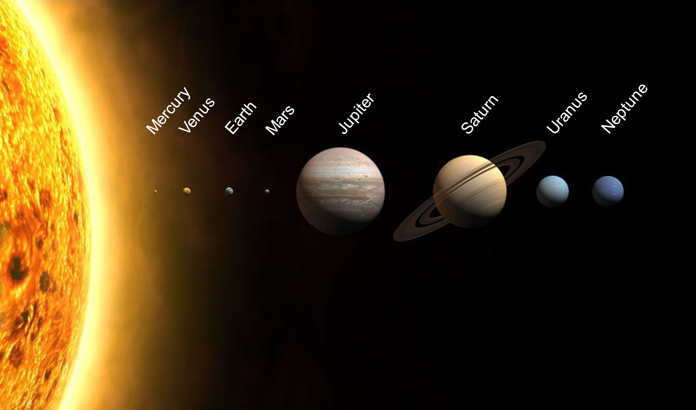

Figure 1.1 The Solar System

## Discovery and exploration

For most of history, humanity did not recognize or understand the concept of the Solar System. Most people up to the Late Middle Ages–Renaissance believed Earth to be stationary at the centre of the universe and categorically different from the divine or ethereal objects that moved through the sky. Although the Greek philosopher Aristarchus of Samos had speculated on a heliocentric reordering of the cosmos, Nicolaus Copernicus was the first to develop a mathematically predictive heliocentric system.

In the 17th century, Galileo discovered that the Sun was marked with sunspots, and that Jupiter had four satellites in orbit around it. Christiaan Huygens followed on from Galileo's discoveries by discovering Saturn's moon Titan and the shape of the rings of Saturn.[14] Edmond Halley realised in 1705 that repeated sightings of a comet were recording the same object, returning regularly once every 75–76 years. This was the first evidence that anything other than the planets orbited the Sun. Around this time (1704), the term "Solar System" first appeared in English. In 1838, Friedrich Bessel successfully measured a stellar parallax, an apparent shift in the position of a star created by Earth's motion around the Sun, providing the first direct, experimental proof of heliocentrism. Improvements in observational astronomy and the use of unmanned spacecraft have since enabled the detailed investigation of other bodies orbiting the Sun.

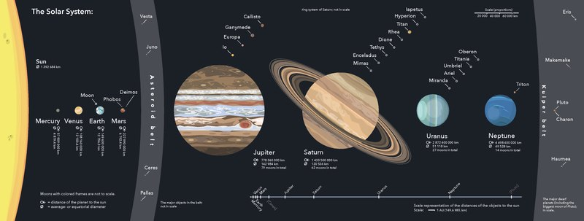

Figure 1.2 Overview of the Solar System

## Structure and composition

The principal component of the Solar System is the Sun, a G2 main-sequence star that contains 99.86% of the system's known mass and dominates it gravitationally. The Sun's four largest orbiting bodies, the giant planets, account for 99% of the remaining mass, with Jupiter and Saturn together comprising more than 90%. The remaining objects of the Solar System (including the four terrestrial planets, the dwarf planets, moons, asteroids, and comets) together comprise less than 0.002% of the Solar System's total mass.

Most large objects in orbit around the Sun lie near the plane of Earth's orbit, known as the ecliptic. The planets are very close to the ecliptic, whereas comets and Kuiper belt objects are frequently at significantly greater angles to it. As a result of the formation of the Solar System planets, and most other objects, orbit the Sun in the same direction that the Sun is rotating (counter-clockwise, as viewed from above Earth's north pole). There are exceptions, such as Halley's Comet. Also, most of the larger moons orbit their planets in this prograde direction and most larger objects rotate themselves in the same direction (with Venus being a notable retrograde exception).

The overall structure of the charted regions of the Solar System consists of the Sun, four relatively small inner planets surrounded by a belt of mostly rocky asteroids, and four giant planets surrounded by the Kuiper belt of mostly icy objects. Astronomers sometimes informally divide this structure into separate regions. The inner Solar System includes the four terrestrial planets and the asteroid belt. The outer Solar System is beyond the asteroids, including the four giant planets. Since the discovery of the Kuiper belt, the outermost parts of the Solar System are considered a distinct region consisting of the objects beyond Neptune.

Most of the planets in the Solar System have secondary systems of their own, being orbited by planetary objects called natural satellites, or moons (two of which, Titan and Ganymede, are larger than the planet Mercury), and, in the case of the four giant planets, by planetary rings, thin bands of tiny particles that orbit them in unison. Most of the largest natural satellites are in synchronous rotation, with one face permanently turned toward their parent.

## Formation and evolution

The Solar System formed 4.568 billion years ago from the gravitational collapse of a region within a large molecular cloud. This initial cloud was likely several light-years across and probably birthed several stars. As is typical of molecular clouds, this one consisted mostly of hydrogen, with some helium, and small amounts of heavier elements fused by previous generations of stars. As the region that would become the Solar System, known as the pre-solar nebula, collapsed, conservation of angular momentum caused it to rotate faster. The centre, where most of the mass collected, became increasingly hotter than the surrounding disc. As the contracting nebula rotated faster, it began to flatten into a protoplanetary disc with a diameter of roughly 200 AU and a hot, dense protostar at the centre. The planets formed by accretion from this disc, in which dust and gas gravitationally attracted each other, coalescing to form ever larger bodies. Hundreds of protoplanets may have existed in the early Solar System, but they either merged or were destroyed, leaving the planets, dwarf planets, and leftover minor bodies.

## Solar System Data

|  |  |  |  |  |  |  |  |  |  |
| --- | --- | --- | --- | --- | --- | --- | --- | --- | --- |
|  | Sun | Mercury | Venus | Earth | Mars | Jupiter | Saturn | Uranus | Neptune |
| Average Distance from Sun (million km) |  | 57.91 | 108.2 | 149.6 | 227.9 | 778.3 | 1427 | 2871 | 4497 |
| Average Distance from Sun (AU) |  | 0.387 | 0.723 | 1 | 1.524 | 5.203 | 9.537 | 19.191 | 30.069 |
| Opposition Magnitude | -26.7 | -1.8 | -4.3 |  | -2.01 | -2.7 | 0.67 | 5.52 | 7.84 |
| Equatorial Diameter (km) | 1392500 | 4880 | 12104 | 12756 | 6794 | 142984 | 120536 | 51118 | 49528 |
| Polar Flattening | <0.01 | 0 | 0 | 0.003353 | 0.006476 | 0.06487 | 0.09796 | 0.02293 | 0.01708 |
| Natural Satellites Discovered to Date (Number of Moons) |  | 0 | 0 | 1 | 2 | 67 | 62 | 27 | 14 |
| Mass (1024 kg) | 1990000 | 0.33 | 4.87 | 5.974 | 0.642 | 1899 | 568.5 | 86.6 | 102.8 |
| Mass (Earths) | 333000 | 0.055 | 0.815 | 1 | 0.107 | 318 | 95.2 | 14.5 | 17.4 |
| Orbital Period Sidereal |  | 87.96 days | 224.68 days | 365.26 days | 686.95 days | 11.862 years | 29.546 years | 84.07 years | 164.81 years |
| Orbital Inclination |  | 7.01° | 3.39° | 0° | 1.85° | 1.30° | 2.49° | 0.77° | 1.77° |
| Synodic Period (days) |  | 115.9 | 583.9 |  | 779.9 | 398.9 | 378.1 | 369.7 | 367.5 |
| Rotational Period (length of days) | 25-29d | 58.64d | 243.0 days (R) | 23h56.07m | 24h37.34m | 9h50m- 9h55m | 10h14m- 10h48m | 17h14.5m (R) | 16h06.6m |
| Axial Tilt | 7.25° | 0° | 177.40° | 23.40° | 25.20° | 3.10° | 26.70° | 97.80° | 28.30° |
| Volume (Earths) | 1300000 | 0.06 | 0.86 | 1 | 0.15 | 1323 | 752 | 64 | 54 |
| Albedo |  | 0.106 | 0.65 | 0.367 | 0.15 | 0.52 | 0.47 | 0.51 | 0.41 |

Table 1 Solar System Data Table [2]

# The Earth

## Introduction

Earth is the third planet from the Sun and the only astronomical object known to harbor life. According to radiometric dating and other evidence, Earth formed over 4.5 billion years ago. Earth's gravity interacts with other objects in space, especially the Sun and the Moon, which is Earth's only natural satellite. Earth orbits around the Sun in 365.256 days, a period known as an Earth sidereal year. During this time, Earth rotates about its axis about 366.256 times. [3]

Earth's axis of rotation is tilted with respect to its orbital plane, producing seasons on Earth. The gravitational interaction between Earth and the Moon causes tides, stabilizes Earth's orientation on its axis, and gradually slows its rotation. Earth is the densest planet in the Solar System and the largest and most massive of the four rocky planets.

Earth's outer layer (lithosphere) is divided into several rigid tectonic plates that migrate across the surface over many millions of years. About 71% of Earth's surface is covered with water, mostly by oceans. The remaining 29% is land consisting of continents and islands that together contain many lakes, rivers and other fresh water, which, together with the oceans, constitute the hydrosphere. The majority of Earth's polar regions are covered in ice, including the Antarctic ice sheet and the sea ice of the Arctic ice pack. Earth's interior remains active with a solid iron inner core, a liquid outer core that generates Earth's magnetic field, and a convecting mantle that drives plate tectonics.

Within the first billion years of Earth's history, life appeared in the oceans and began to affect Earth's atmosphere and surface, leading to the proliferation of anaerobic and, later, aerobic organisms. Some geological evidence indicates that life may have arisen as early as 4.1 billion years ago. Since then, the combination of Earth's distance from the Sun, physical properties and geological history have allowed life to evolve and thrive. In the history of life on Earth, biodiversity has gone through long periods of expansion, occasionally punctuated by mass extinctions. Over 99% of all species that ever lived on Earth are extinct. Estimates of the number of species on Earth today vary widely; most species have not been described. Over 7.7 billion humans live on Earth and depend on its biosphere and natural resources for their survival. Politically, the world has around 200 sovereign states.

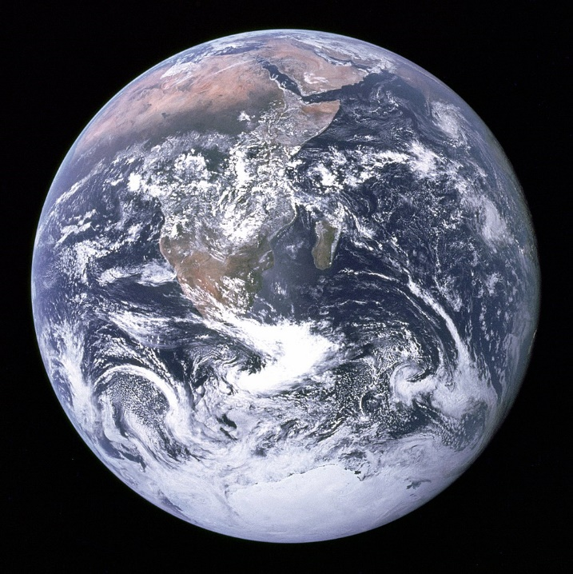

Figure 2.1 The Earth

## Chronology

### Formation

The oldest material found in the Solar System is dated to 4.5672±0.0006 billion years ago (Bya). By 4.54±0.04 Bya the primordial Earth had formed. The bodies in the Solar System formed and evolved with the Sun. In theory, a solar nebula partitions a volume out of a molecular cloud by gravitational collapse, which begins to spin and flatten into a circumstellar disk, and then the planets grow out of that disk with the Sun. A nebula contains gas, ice grains, and dust (including primordial nuclides). According to nebular theory, planetesimals formed by accretion, with the primordial Earth taking 10–20 million years (Mys) to form.

A subject of research is the formation of the Moon, some 4.53 Bya. A leading hypothesis is that it was formed by accretion from material loosed from Earth after a Mars-sized object, named Theia, hit Earth. In this view, the mass of Theia was approximately 10 percent of Earth, it hit Earth with a glancing blow and some of its mass merged with Earth. Between approximately 4.1 and 3.8 Bya, numerous asteroid impacts during the Late Heavy Bombardment caused significant changes to the greater surface environment of the Moon and, by inference, to that of Earth.

### Geological history

Earth's atmosphere and oceans were formed by volcanic activity and outgassing. Water vapor from these sources condensed into the oceans, augmented by water and ice from asteroids, protoplanets, and comets. In this model, atmospheric "greenhouse gases" kept the oceans from freezing when the newly forming Sun had only 70% of its current luminosity. By 3.5 Bya, Earth's magnetic field was established, which helped prevent the atmosphere from being stripped away by the solar wind.

A crust formed when the molten outer layer of Earth cooled to form a solid. The two models that explain land mass propose either a steady growth to the present-day forms or, more likely, a rapid growth early in Earth history[49] followed by a long-term steady continental area. Continents formed by plate tectonics, a process ultimately driven by the continuous loss of heat from Earth's interior. Over the period of hundreds of millions of years, the supercontinents have assembled and broken apart. Roughly 750 million years ago (Mya), one of the earliest known supercontinents, Rodinia, began to break apart. The continents later recombined to form Pannotia 600–540 Mya, then finally Pangaea, which also broke apart 180 Mya.

The present pattern of ice ages began about 40 Mya, and then intensified during the Pleistocene about 3 Mya. High-latitude regions have since undergone repeated cycles of glaciation and thaw, repeating about every 40,000–100,000 years. The last continental glaciation ended 10,000 years ago.

# References

|  |  |
| --- | --- |
| [1] | "Wikipedia," [Online]. Available: https://en.wikipedia.org/wiki/Solar_System. |
| [2] | "Stardome Observatory Planetarium," [Online]. Available: https://www.stardome.org.nz/wp-content/uploads/2016/10/WEB-PDFs_solar-system-chart_2016.pdf. |
| [3] | "Wikipedia," [Online]. Available: https://en.wikipedia.org/wiki/Earth. |